Maths: Higher Revision Guide

Name:

____________

Grade C Key topics:

* Ratio and Proportion
* Adding and subtracting fractions
* Pie Charts
* Drawing graphs e.g. y=3x+2
* Percentage Increase and Decrease
* Stem and Leaf
* Pythagoras
* Area and circumference of a circle

Grade B Key topics:

All of the above plus:

* Simultaneous equations
* Compound interest
* Cumulative frequency
* Factorising and Expanding
* Standard form
* Trigonometry ( SOH CAH TOA)

Grade A Key topics:

All of the above plus:

* Circle theorems (angles within a circle)
* Using the quadratic equation
* Probability
* Sine and Cosine rule
* Histograms

Ratio: Key facts

Example

A drink is made up of orange & grapefruit in the ratio 2 : 3. If there is 500ml of drink in a cup, how much is orange and how much is grapefruit.

Step 1 Add up the ratio numbers 2 + 3 = **5**

Step 2 Divide the total by this number 500  5 = 100ml

Step 3 Multiply this by the proportion we are interested in

So orange = 2 x 100 = 200ml

grapefruit = 3 x 100 = 300ml

Questions to try

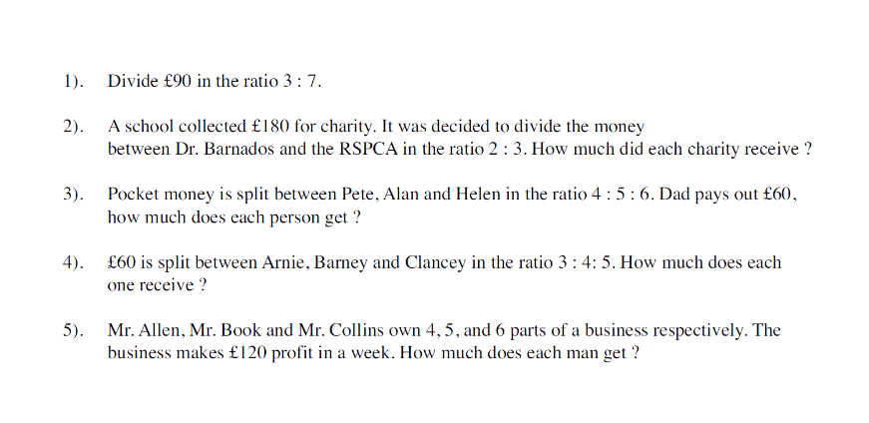

Adding and subtracting fractions : Key facts

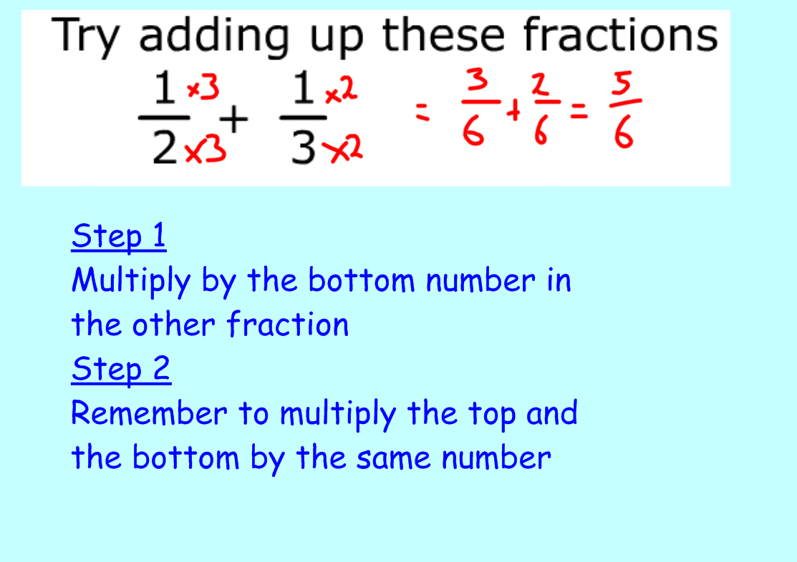

Questions to try

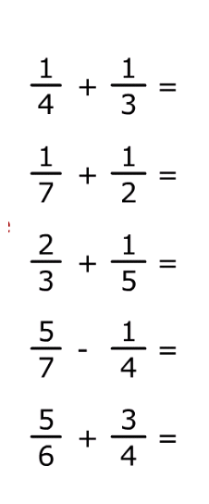

Pie Charts: Key facts

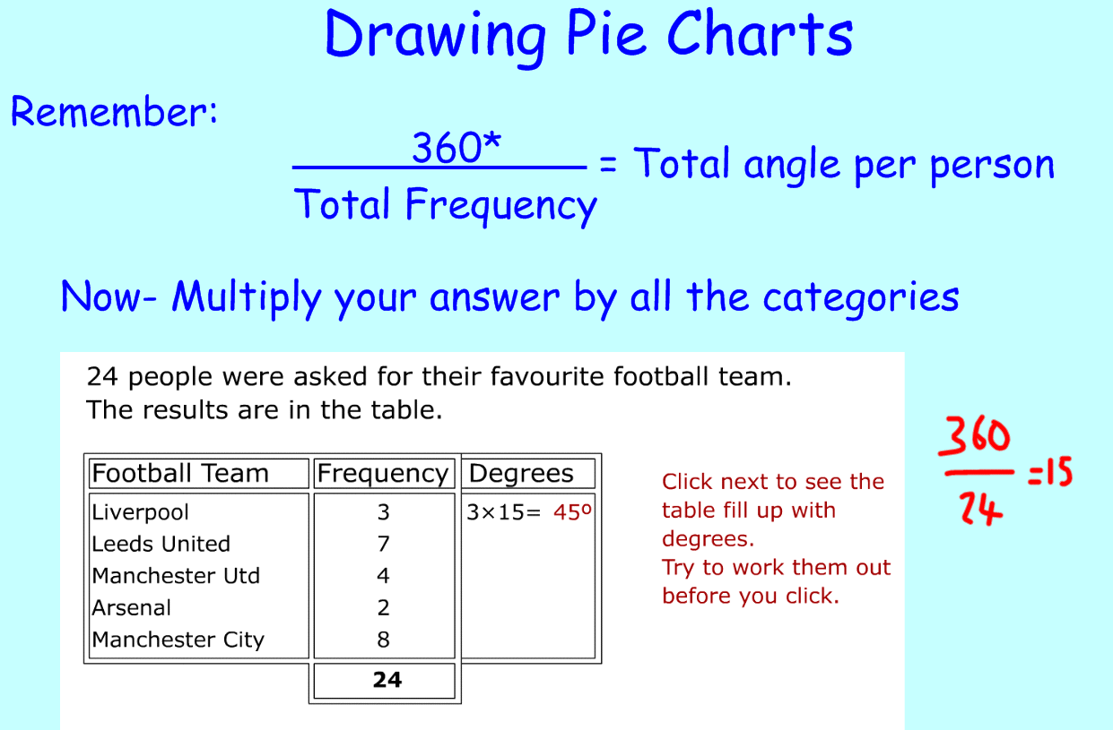

Question to try:

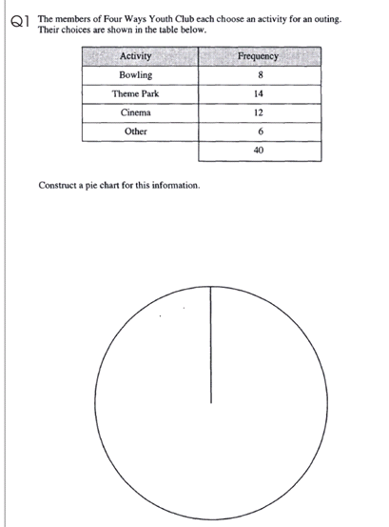

Drawing graphs: Key facts

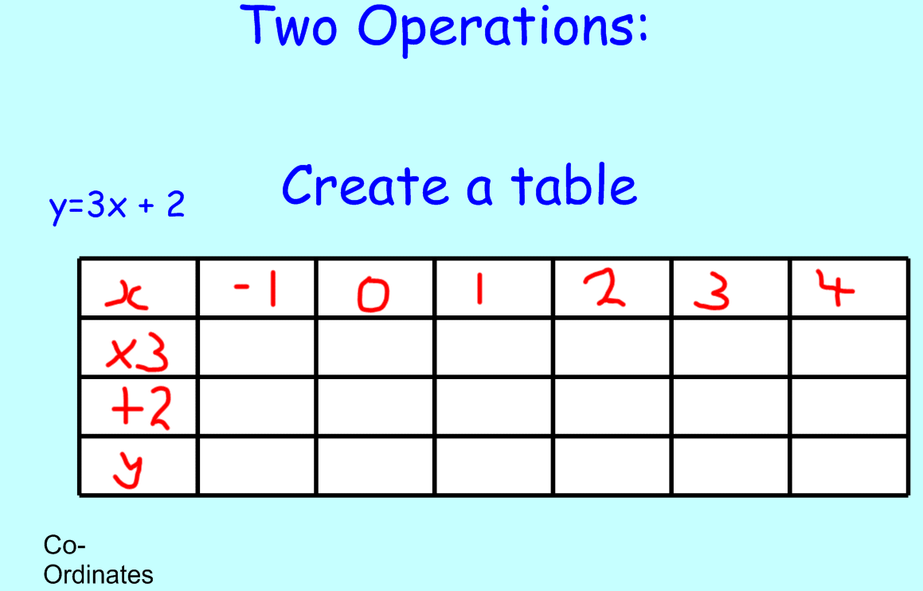

Questions to try (Just Draw the tables)

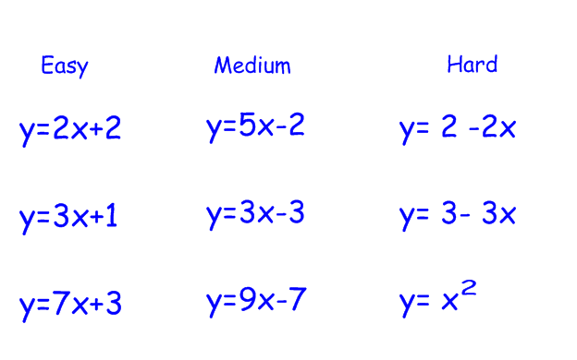

Percentage Increase and Decrease: Key facts

To find 10% divide by 10

To find 1% divide by 100

Remember to add on or subtract at the end of the question.

Depreciate means subtract in this context.

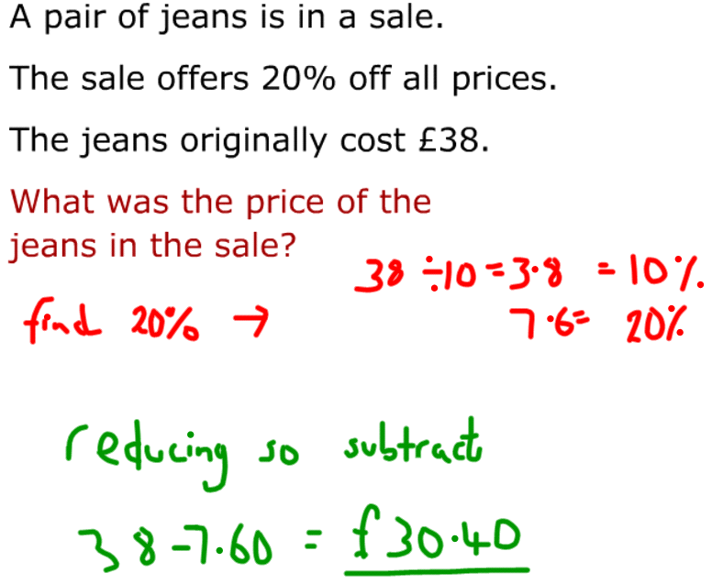

**British Rail have decided to raise ticket prices by 17.5%.**

**Below is a list of prices before the increase. Work out the new ticket prices please.**

**To find 17.5% you need to find 10%. Then halve it to find 5%. Then halve it again to find 2.5%. Then add the three parts up.**

**Liverpool-London Return £60**

**Liverpool-Edinburgh Return £50**

**Liverpool-Paris Return £90**

**Liverpool-Rome Return £130**

Stem and leaf: Key facts

Remember to put on a key!

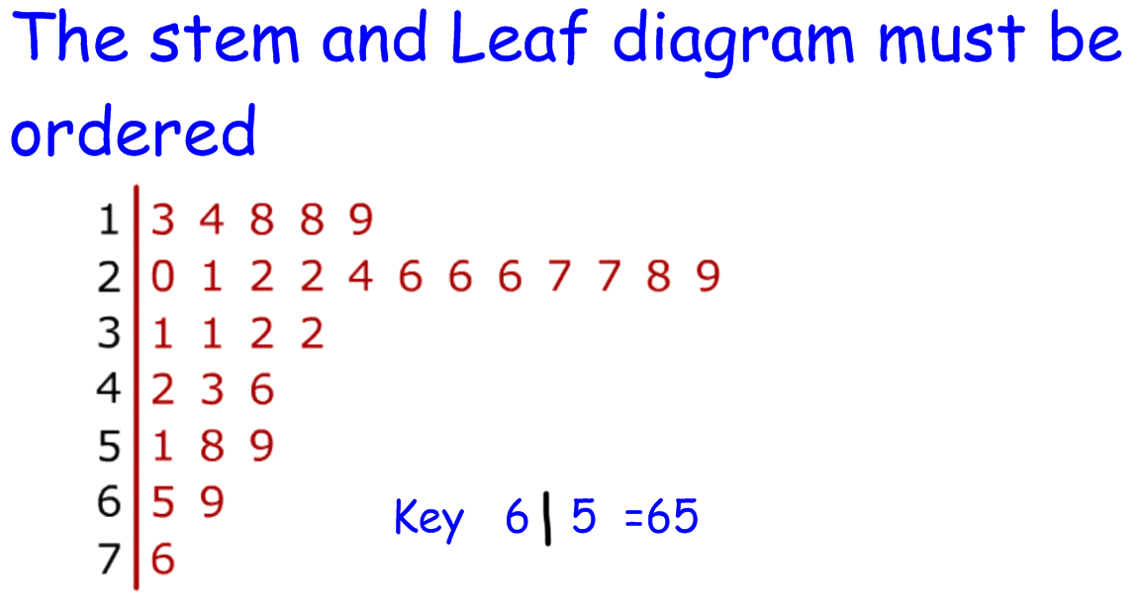Questions to try

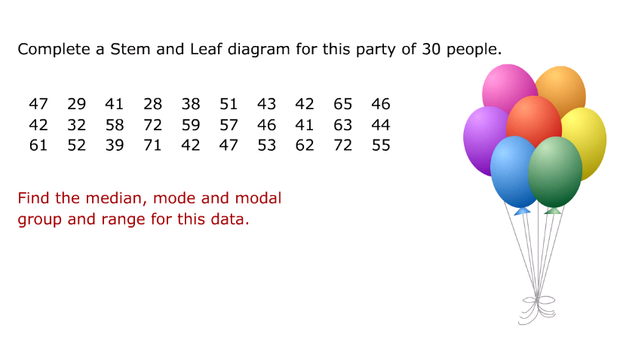

Area and Circumference of a circle

Key facts:

Area of a circle $A=πr^{2}$ or $A=π x r x r$

Circumference of a circle C= $π$ x d

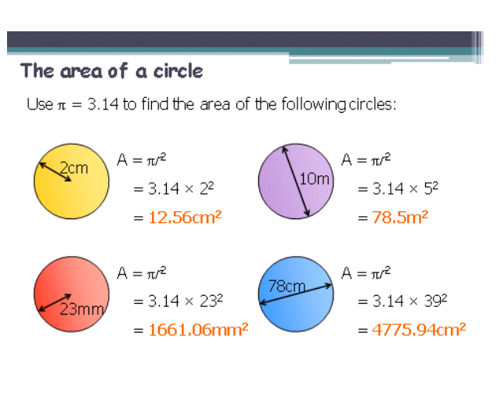

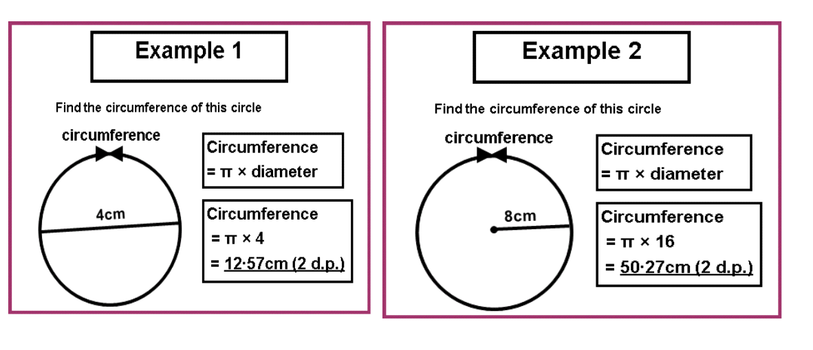

Calculate the area and the circumference of :

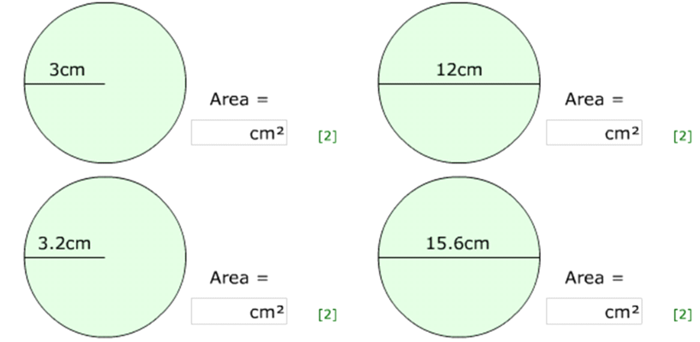

Extension: Tip to find a semicircle half a circle

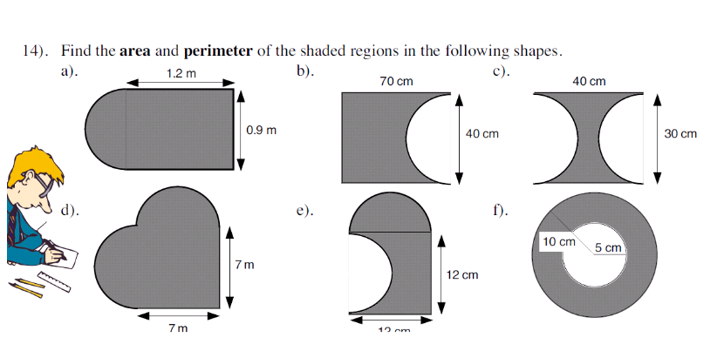

Pythagoras : Key facts

E.g. 1

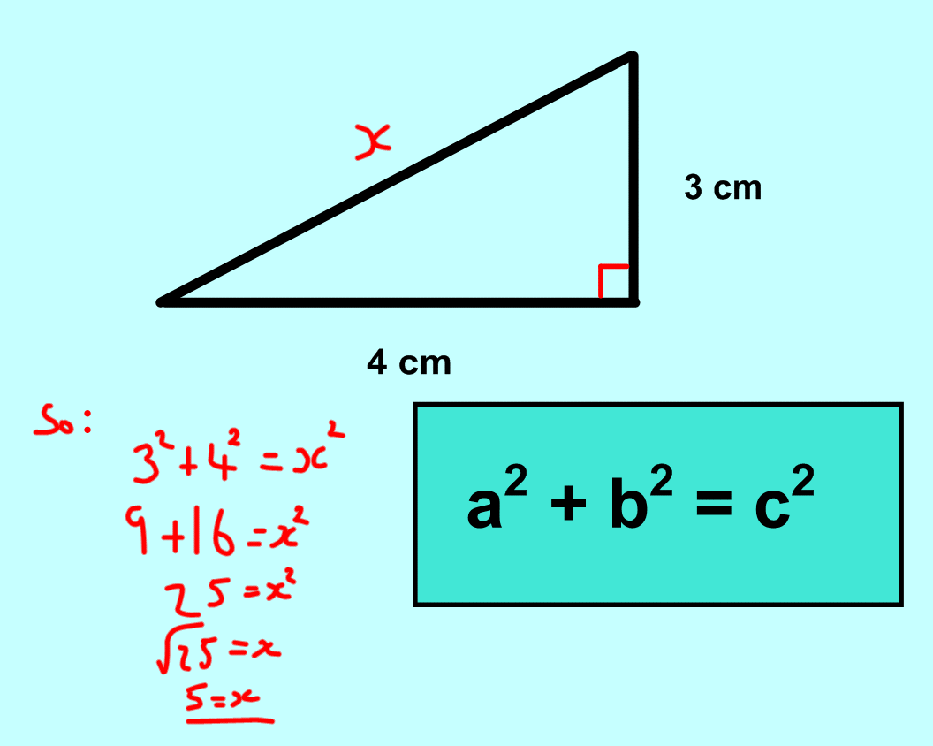

E.g. 2

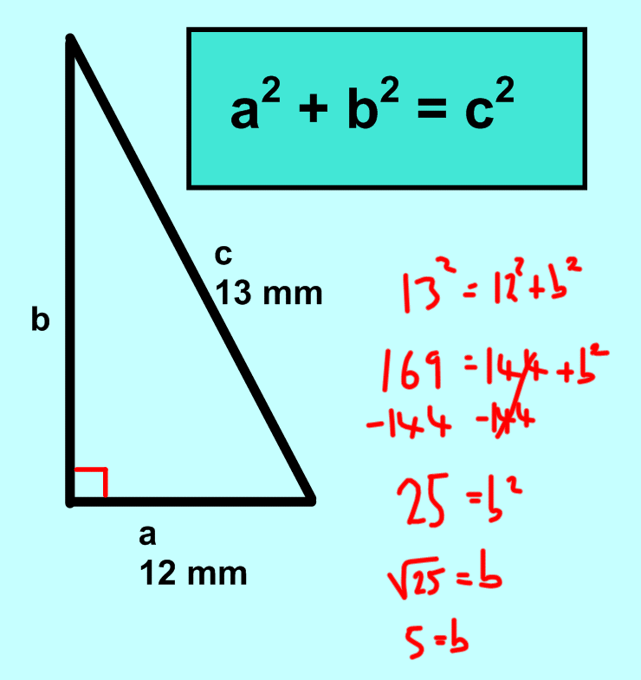

Some to try:

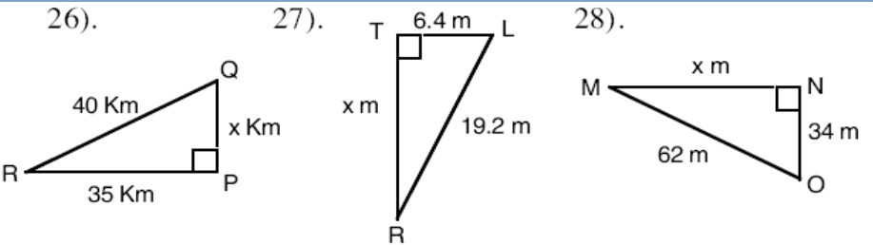 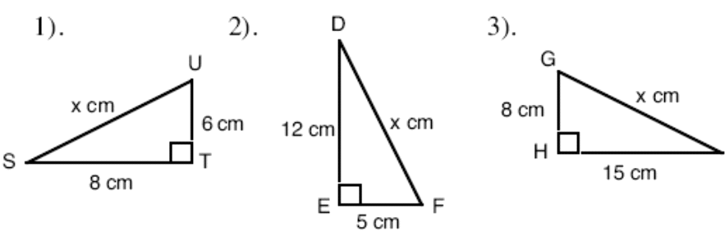Extension:

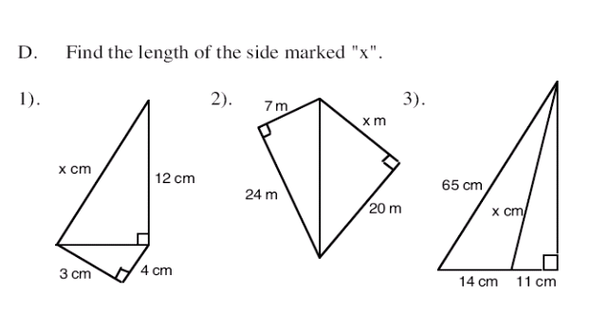

Simultaneous Equations: Key facts

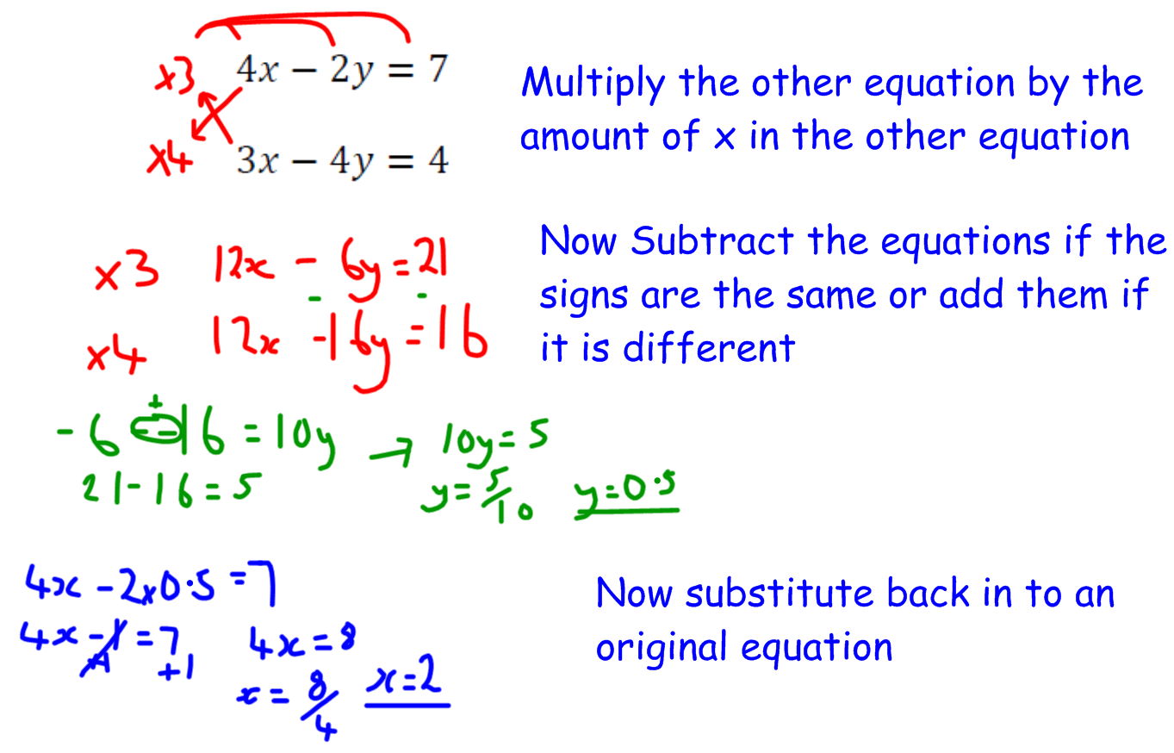

Questions to try:

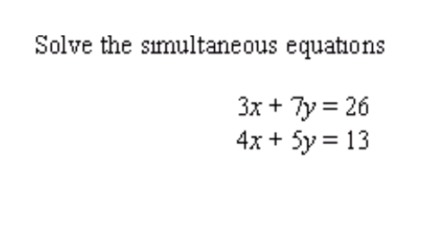

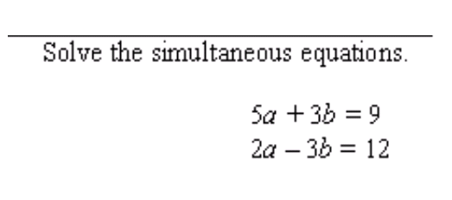

Compound interest: Key facts

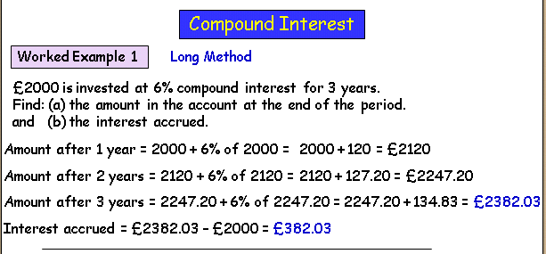

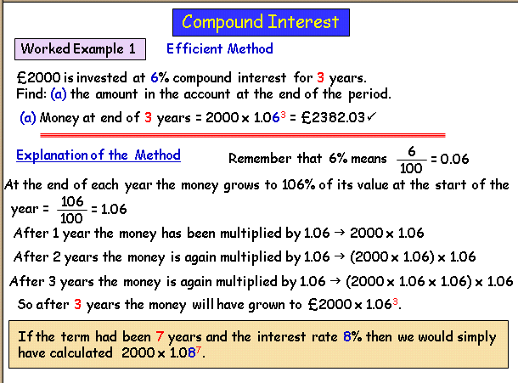

Remember that the amount is decreasing in will reduce every year. Per annum means every year. Depreciate means reducing.

**Q1.** £600 is invested at 5% compound interest for 3 years. Find: (a) the amount in the account at the end of the period. and (b) the interest accrued.

**Q2**. £5000 is invested at 8% compound interest for 4 years. Find: (a) the amount in the account at the end of the period (nearest £) and (b) the interest accrued (nearest £)

**Worked Example 1**:

£2000 is invested at 6% compound interest for 3 years.

Find: (a) the amount in the account at the end of the period and (b) the interest accrued.

Remember with the question below the decimal multiplier will be 100%-8%........

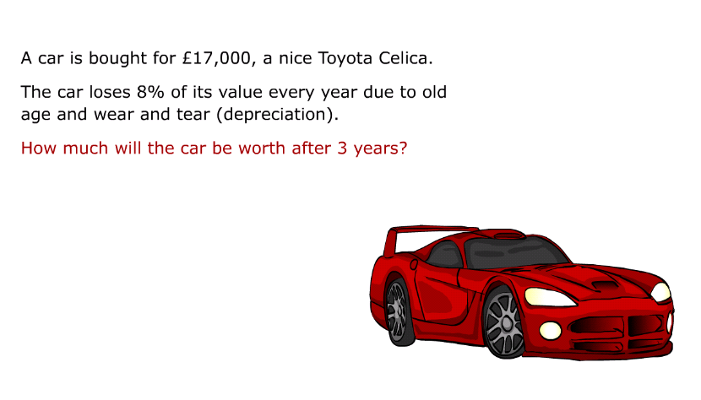

Cumulative Frequency: Key points

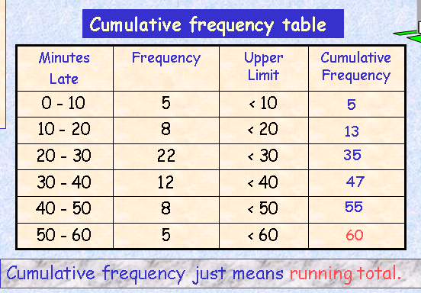

Plot the upper limit!

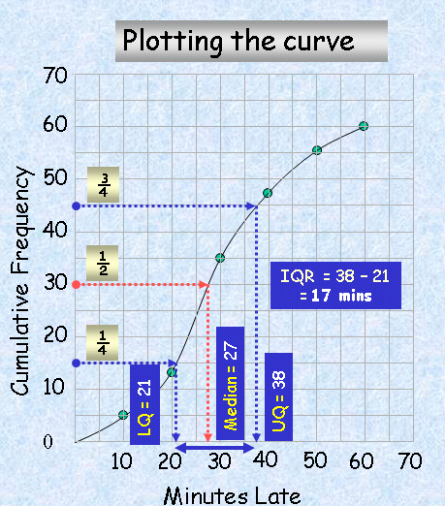

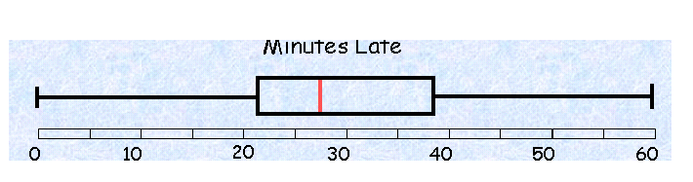

Lowest Lower median Upper Highest score

score Quartile quartile

Question for you to try:

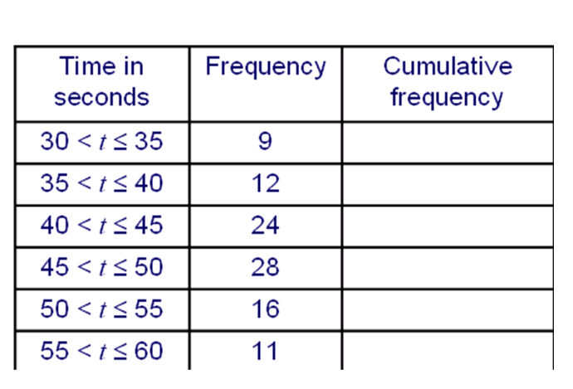

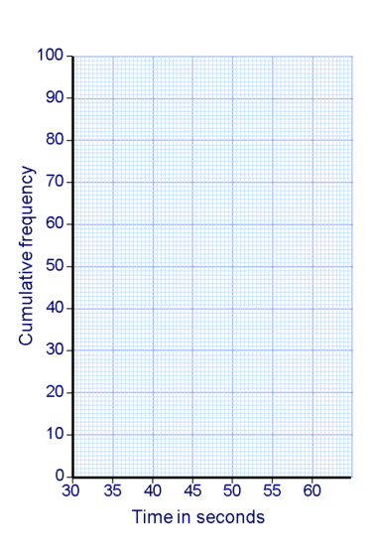

Factorising and expanding: Key points

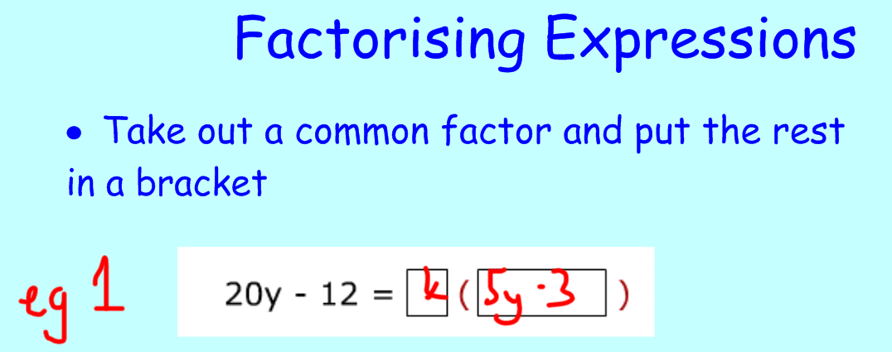

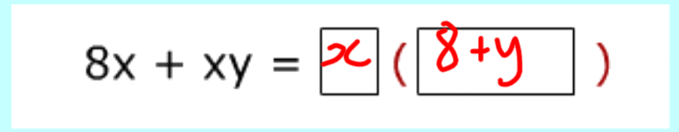

Tip: remember to factorise fully:

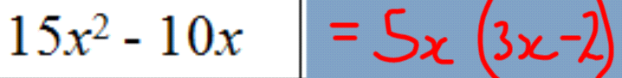

Some to try:

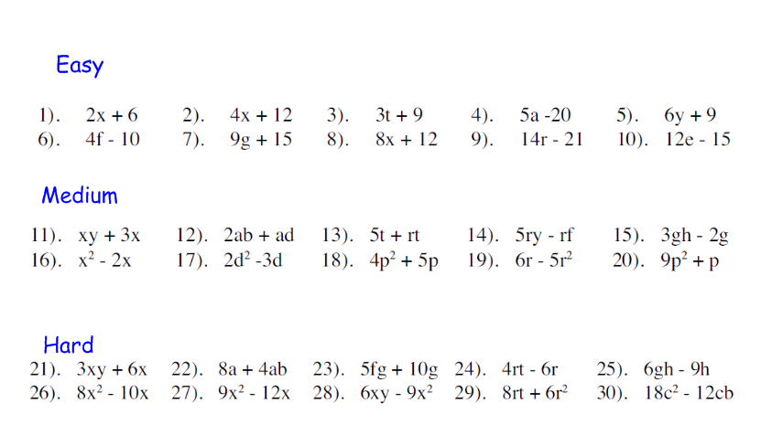

Factorising expressions (2)

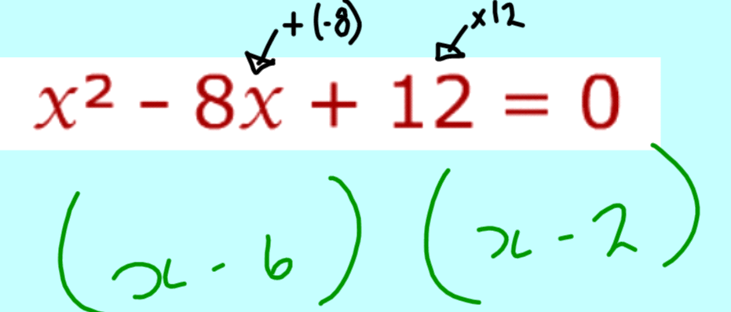

Some to try:

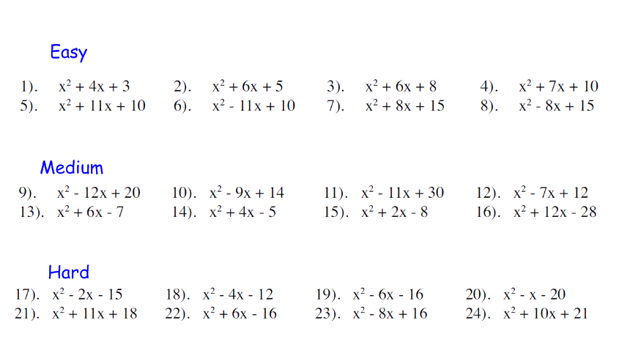

Expanding double brackets

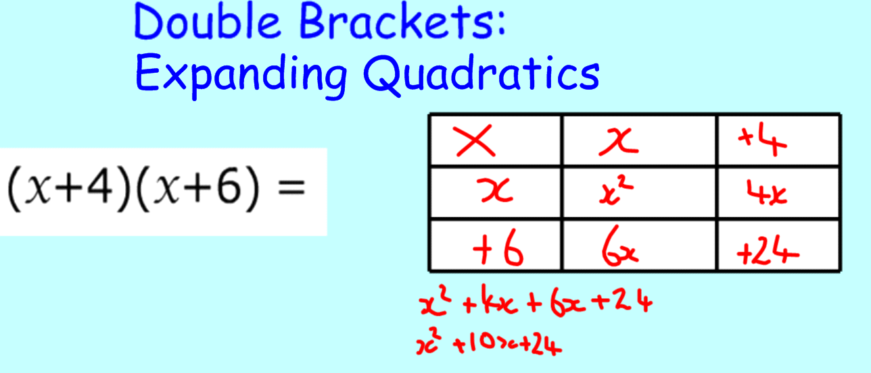

Some to try:

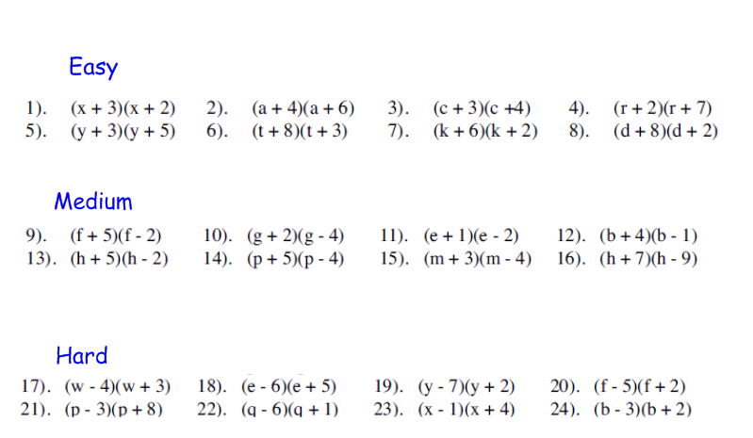

Trigonometry Key points:

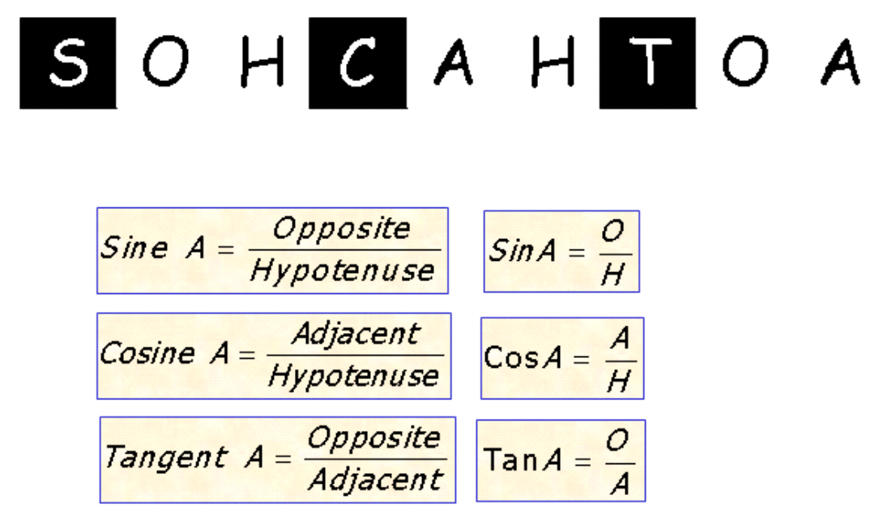

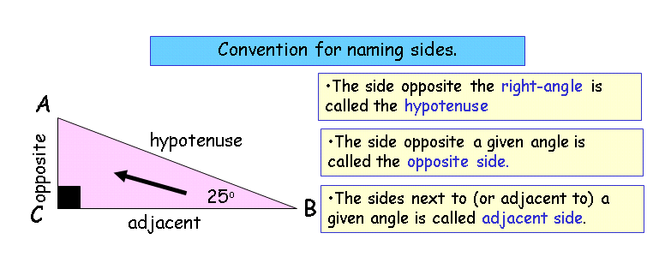

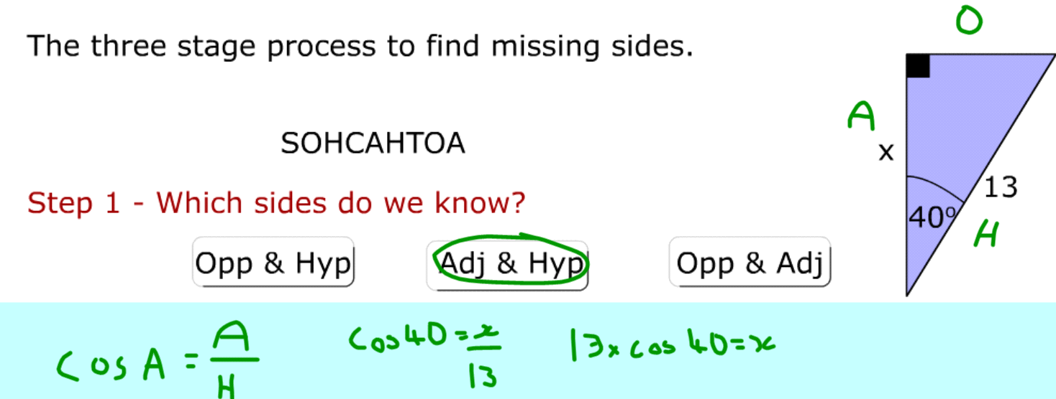

Now put the information into your calculator!

E.g.2

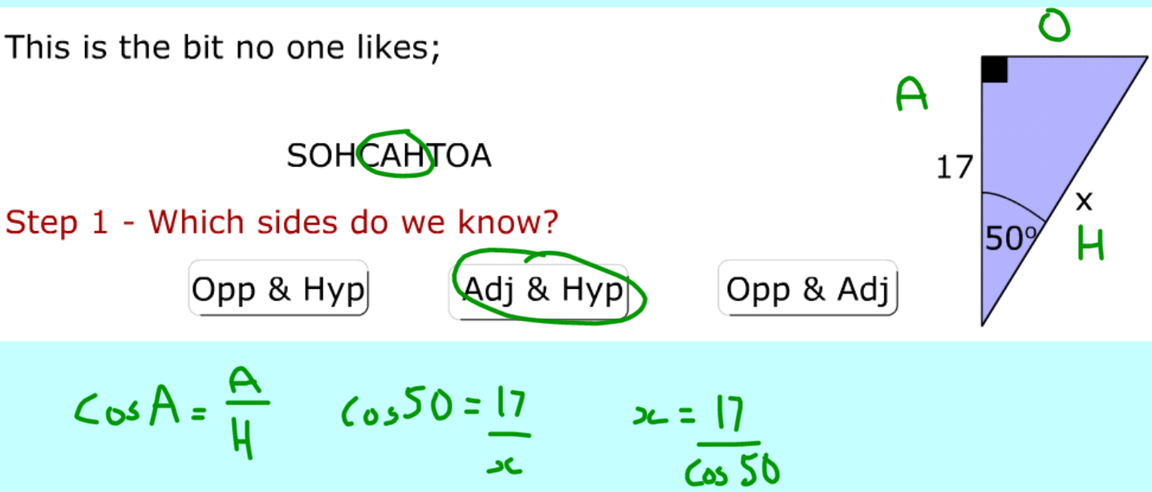

Some for you to try:

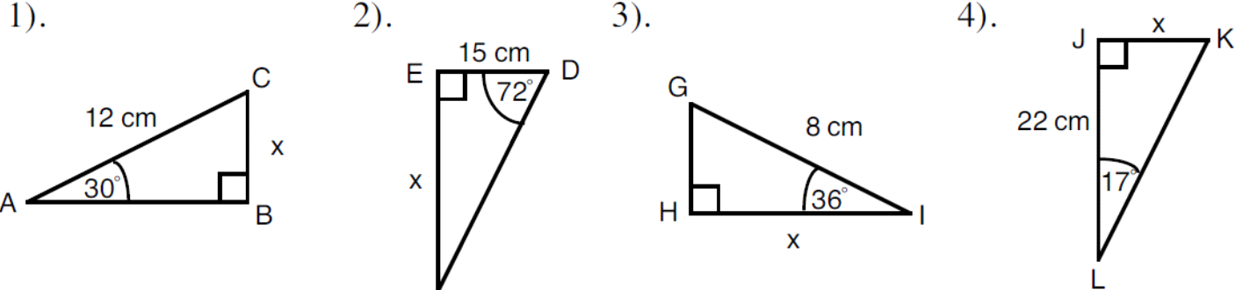

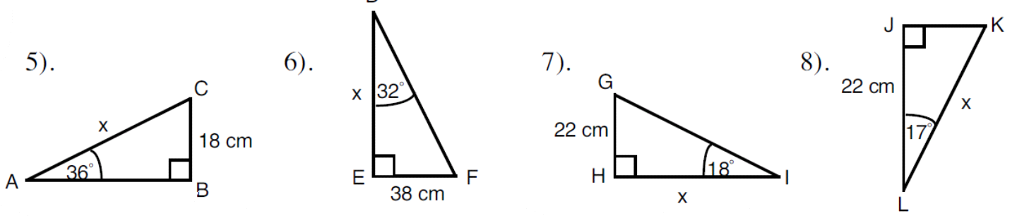

Finding missing angles using trigonometry:

Remember to use the inverse (-1)

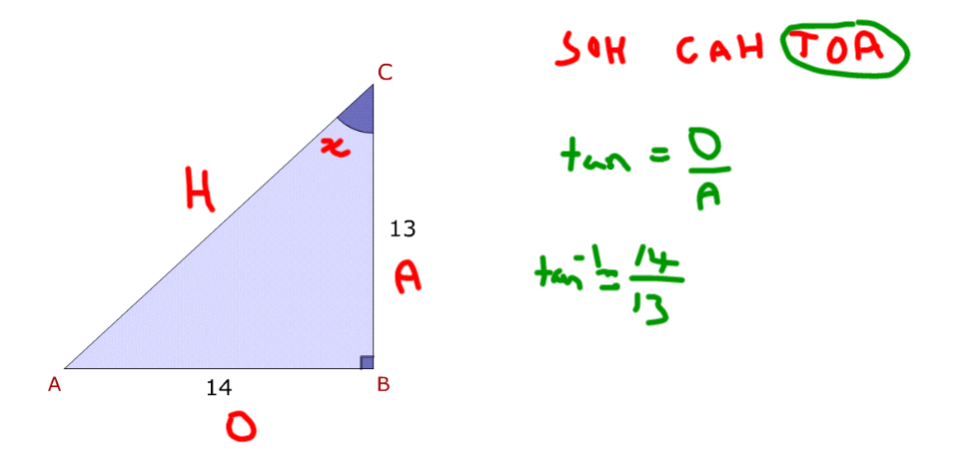

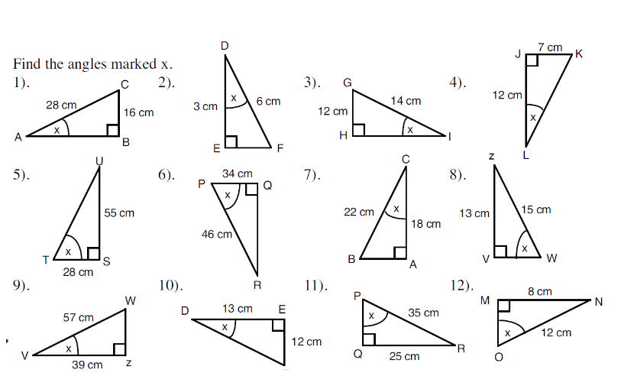

Standard form: key points

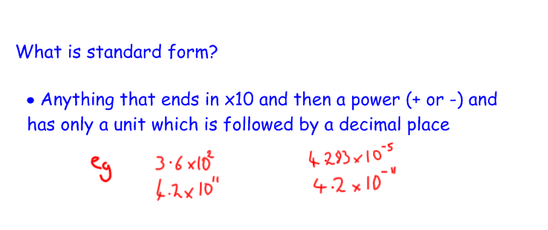

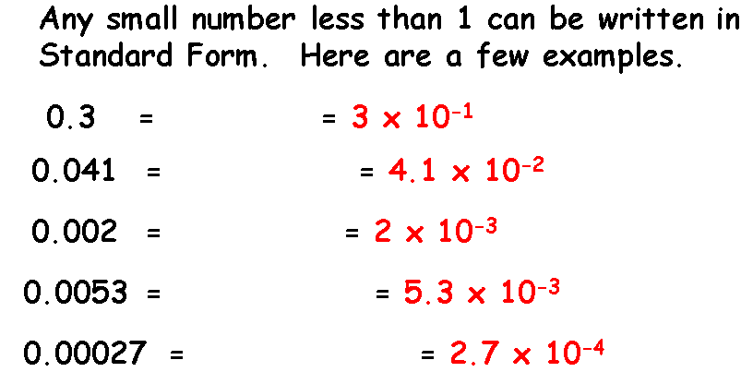

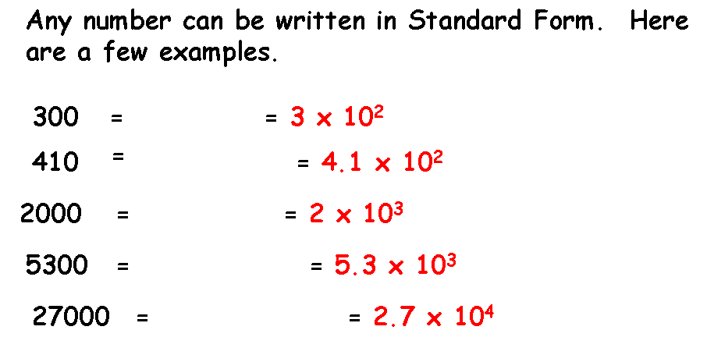

Mixed Questions

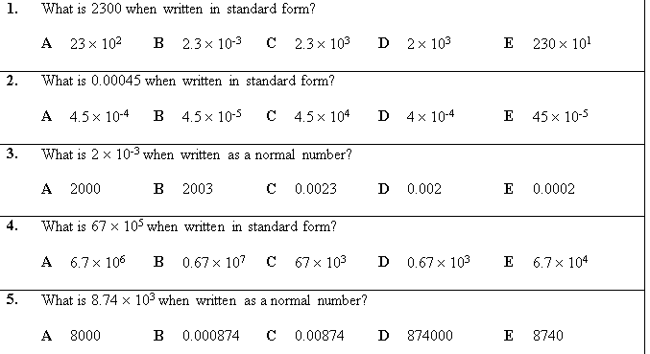

Calculating with standard form remember:

$a^{4}x a^{6 }= a^{10}$ When you multiply powers we add

$a^{10}÷ a^{6 }= a^{4}$ When you divide powers we subtract

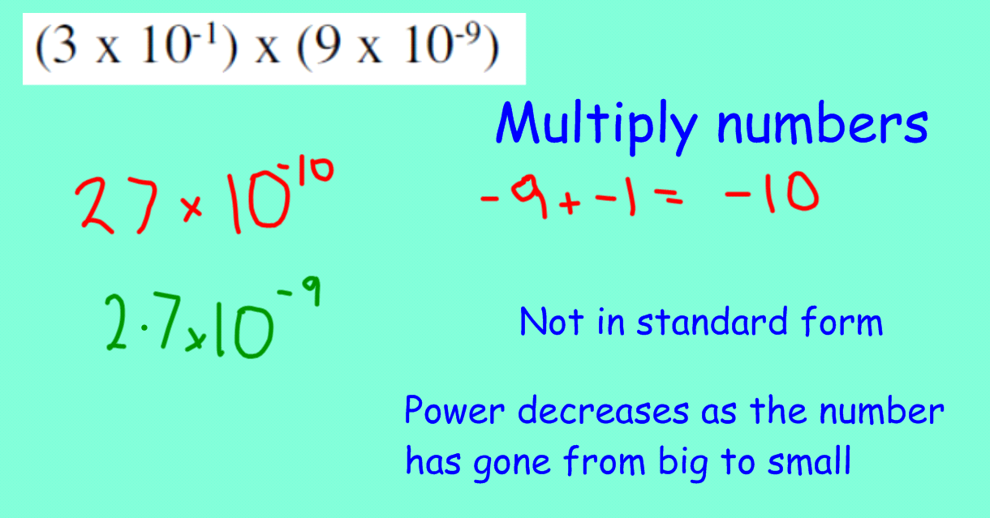

Questions to try:

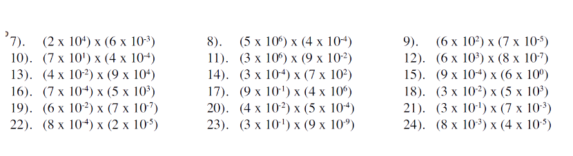

Harder exam question:

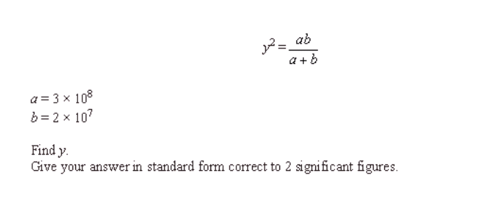

Circle theorems: You need to remember these:

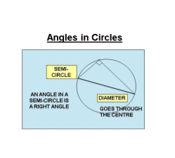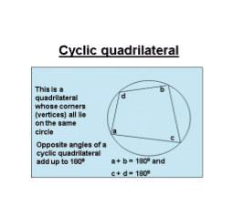

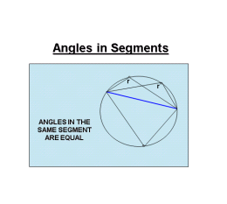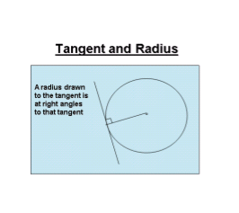

Mr Cottons favourite!

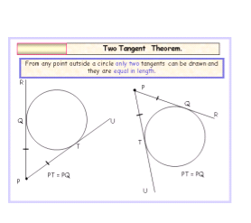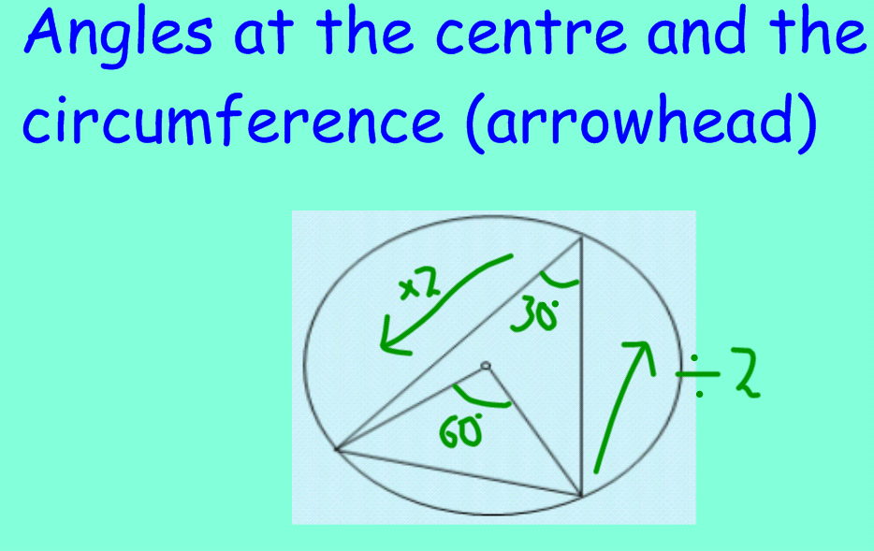

Mixed test questions:

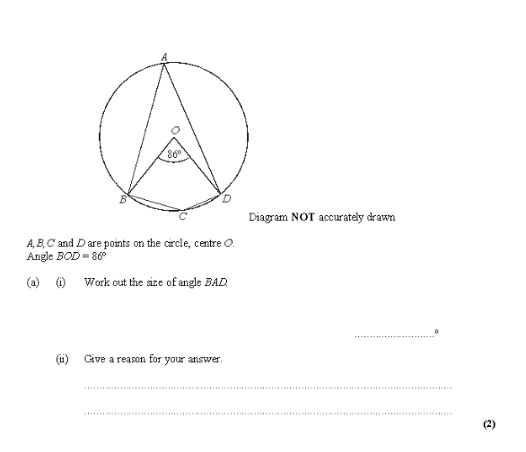

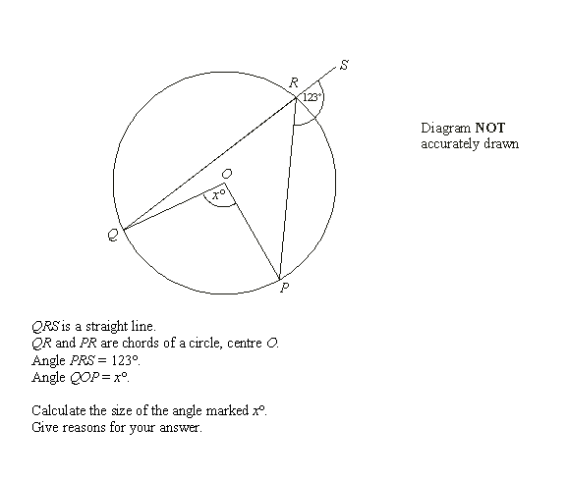

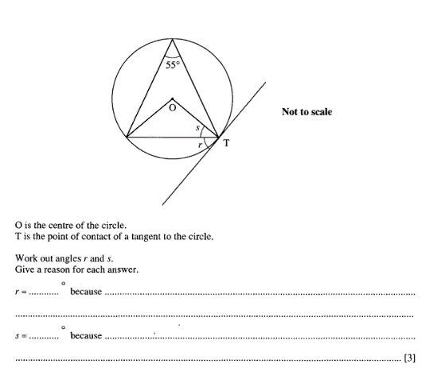

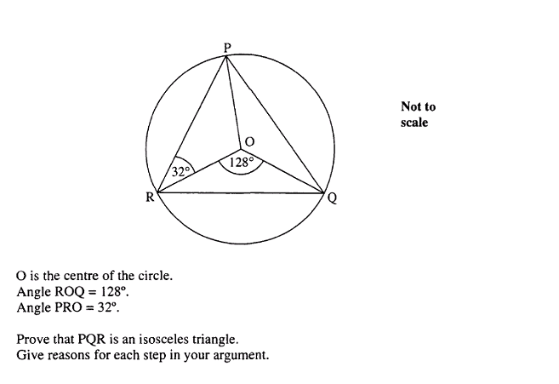

Quadratic Equation: key points

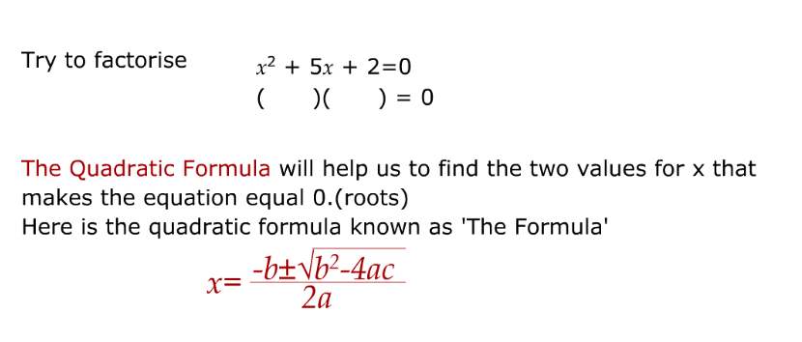

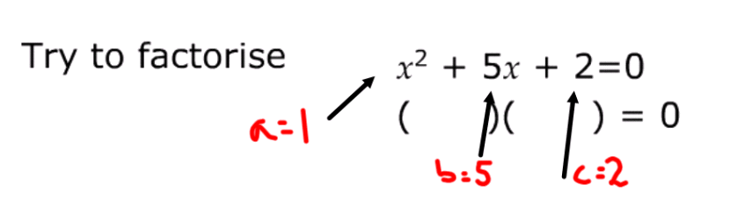

Now substitute into the formula:

$$x=\frac{-5±\sqrt{5^{2}-4×1×2}}{2×1}$$

$$x=\frac{-5±\sqrt{25-8}}{2}$$

$x=\frac{-5+\sqrt{17}}{2}$ or $$x=\frac{-5-\sqrt{17}}{2}$$

Now put into a calculator to work out, you will have two answers:

So x = ___________ or x=________

Some to try: remember to take the ‘-‘ sign if the number is negative!

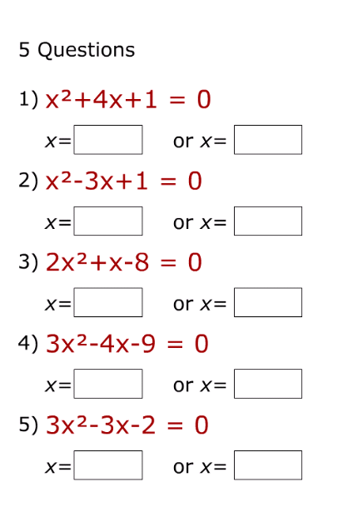

Probability

Key points:

Remember to multiply probabilities (do NOT add)

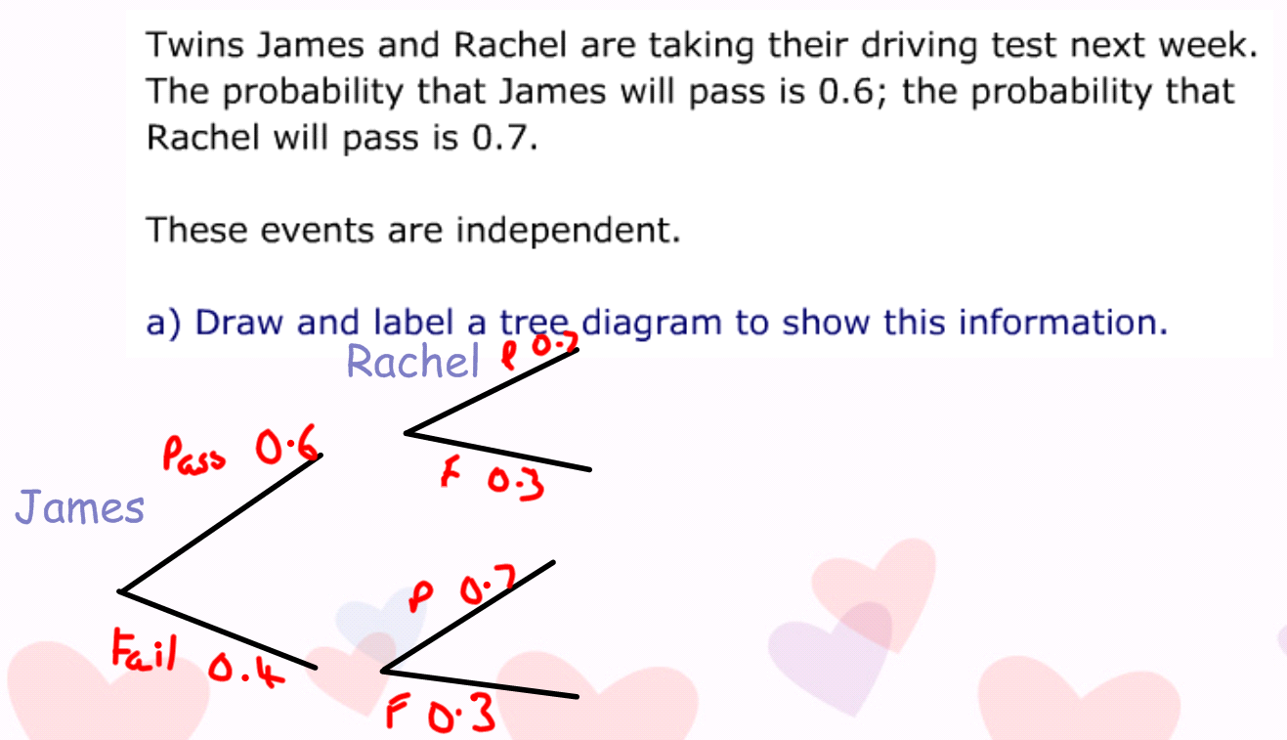

Q. What is the probability that they both pass?

James to Pass is 0.6 Rachel to pass is 0.7

Multiply them together so 0.6 x 0.7 =0.42

Top tip if you can’t multiply decimals convert them to fractions:

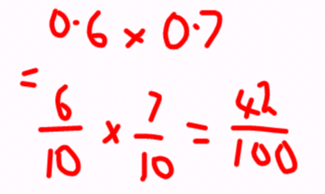

Q. What is the probability only one of them passes?

James to pass 0.6 Rachel to fail 0.3 0.6x0.3=0.18

James to fail 0.4 Rachel to pass 0.7 0.4 x0.7=0.28

Now add your two answers together so 0.18+0.28= 0.46

Questions: Hint draw a tree diagram (probability must add up to one)

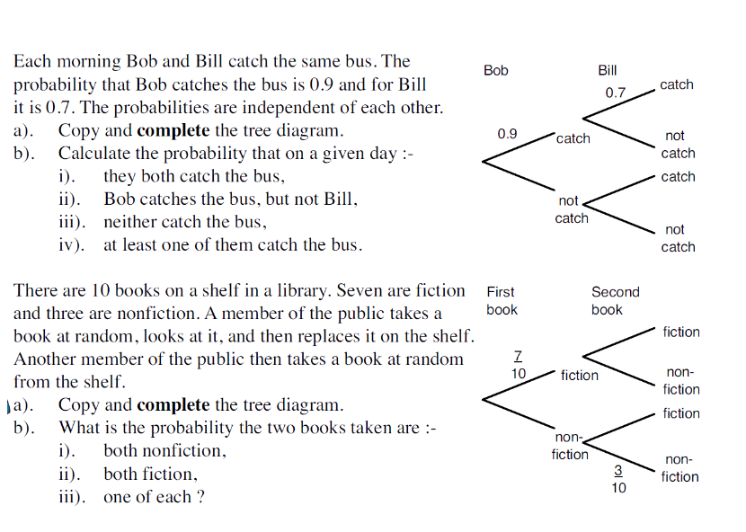

Extension

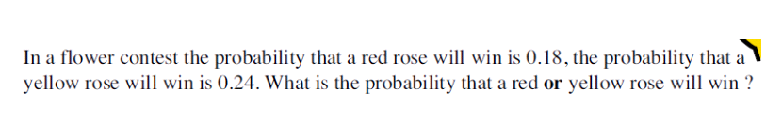

Sine and Cosine rules

These are used only in non-right angled triangles. The formulae will be on your test paper at the front.

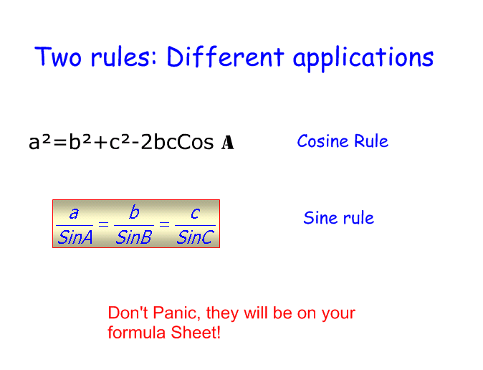

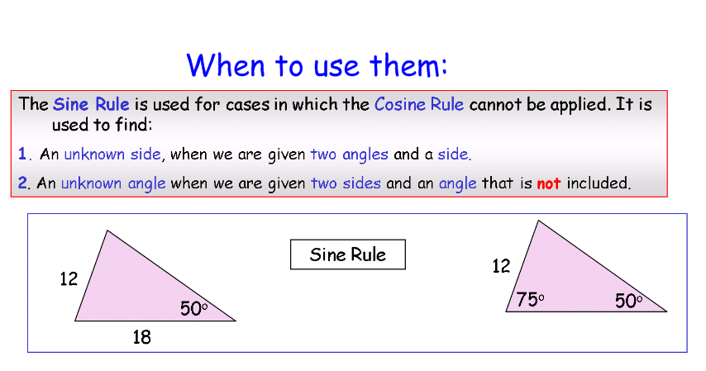

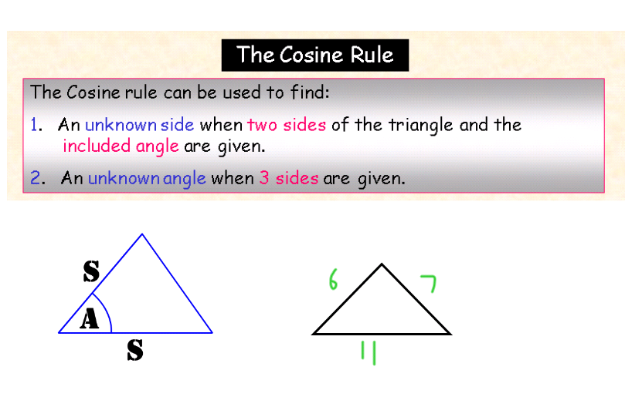

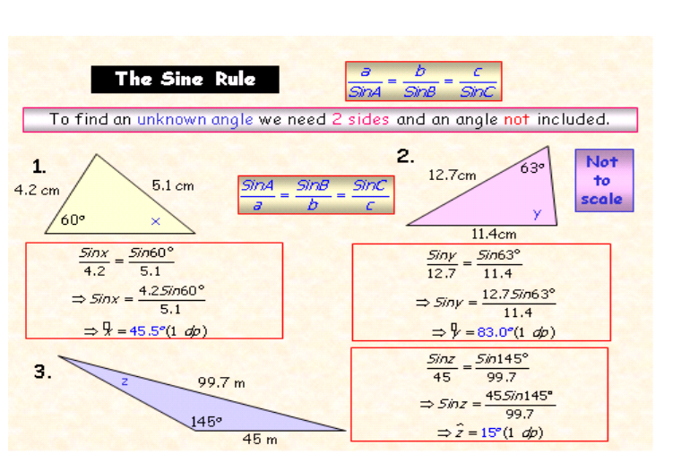

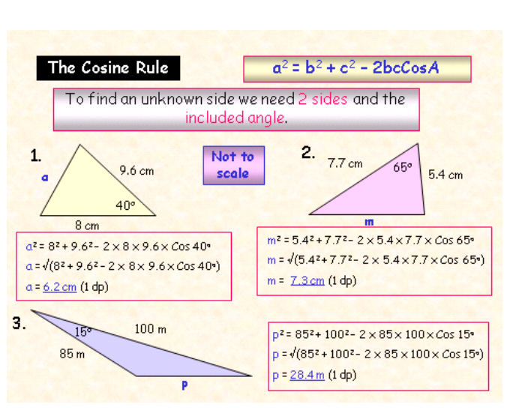

Tip: It does not matter how you label the sides as long as a side and angle are opposite each other e.g.

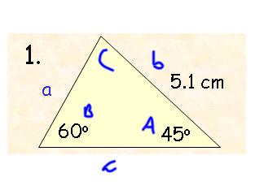

Mixed questions. Find which rule to use first. Find all missing measurements/ angles.

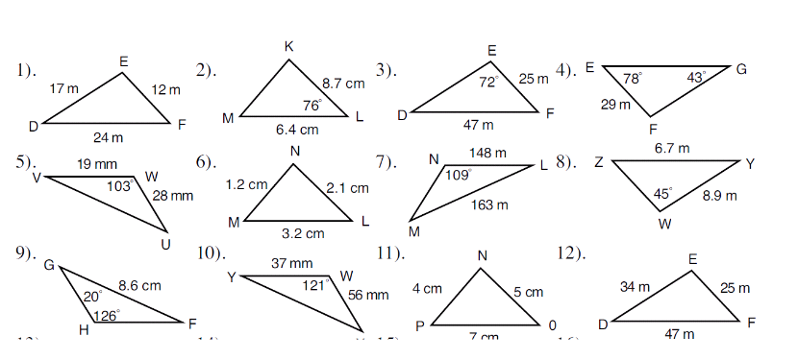

Histograms key facts

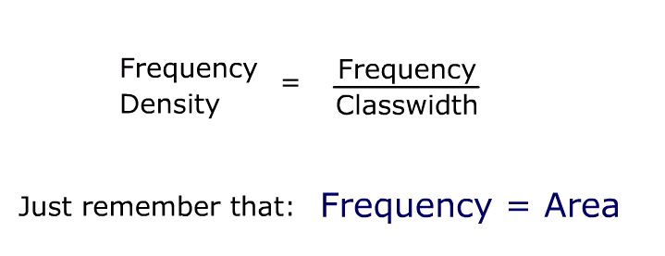

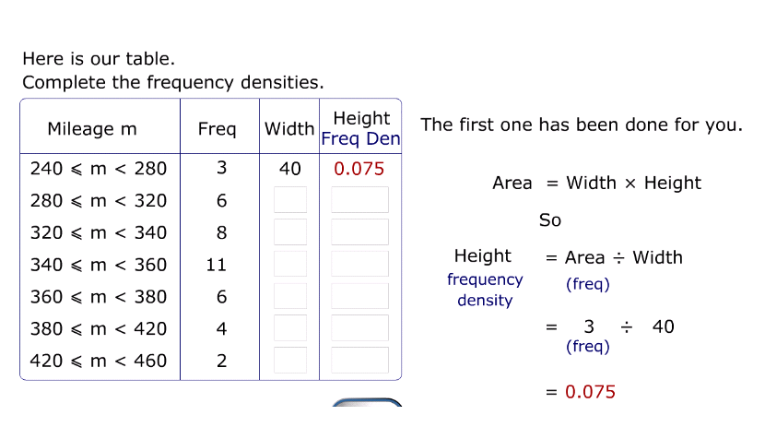

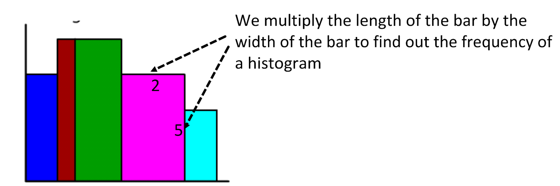

Questions to try

Type 1

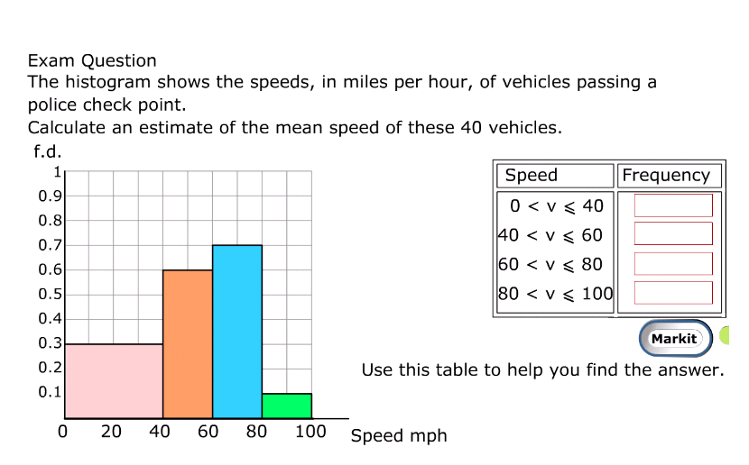

Type 2: Remember to calculate frequency density!

One Monday, Victoria measured the time, in seconds, that individual birds spent on her bird table.

She used this information to complete the frequency table.

|  |  |
| --- | --- |
| Time (*t* seconds) | Frequency |
| 0 < *t*  10 | 8 |
| 10 < *t*  20 | 16 |
| 20 < *t*  25 | 15 |
| 25 < *t*  30 | 12 |
| 30 < *t*  50 | 6 |

(a) Use the table to complete the histogram.

